Assessment 3 Machine Learning Lab
Apurba Koirala
22BCE3799
Guided by: Dr. Sudha S

- Write a program to construct a Bayesian network considering medical data. Use this model to demonstrate the diagnosis of heart patients using standard Heart Disease Data Set. Calculate the accuracy, precision, and recall for your data set.

! pip install --upgrade pgmpy
! pip install pgmpy.models pgmpy.estimators pgmpy.inference

import pandas as pd
from sklearn.model_selection import train_test_split
from sklearn.metrics import accuracy_score, precision_score, recall_score, classification_report, confusion_matrix

from pgmpy.estimators import HillClimbSearch, BIC, BayesianEstimator
from pgmpy.models import DiscreteBayesianNetwork

target = "target"
for col in data.columns:
if col != target and data[col].dtype != "object":
data[col] = pd.qcut(data[col], q=4, duplicates="drop", labels=False).astype(str)

data[target] = data[target].astype(str)

train, test = train_test_split(data, test_size=0.2, random_state=42)

hc = HillClimbSearch(train)
best_model = hc.estimate(scoring_method=BIC(train))

model = DiscreteBayesianNetwork(best_model.edges())
model.fit(train, estimator=BayesianEstimator, prior_type="BDeu")

# Keep only the model's nodes
predictors = list(set(model.nodes()) - {target})
y_pred = model.predict(test[predictors])[target].tolist()
y_true = test[target].tolist()

print("Predictions:", len(y_pred), "out of", len(test))
print("Accuracy:", accuracy_score(y_true, y_pred))
print("Precision:", precision_score(y_true, y_pred, average="weighted"))
print("Recall:", recall_score(y_true, y_pred, average="weighted"))
print("\nClassification Report:\n", classification_report(y_true, y_pred))
print("\nConfusion Matrix:\n", confusion_matrix(y_true, y_pred))

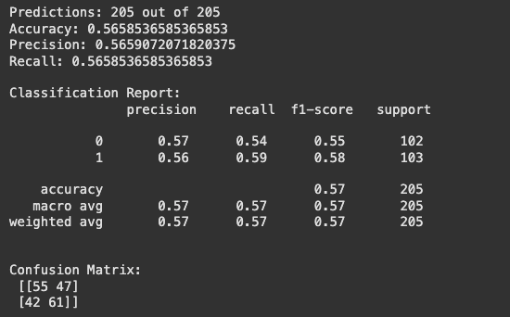
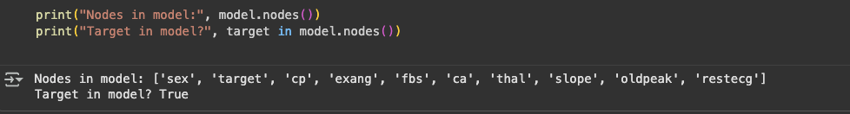

- Implement K Nearest Neighbors algorithm for iris dataset and evaluate the algorithm with accuracy, precision, recall and F1-score.

from sklearn.datasets import load_iris

iris = load_iris()
X = iris.data
y = iris.target

from sklearn.model_selection import train_test_split

X_train, X_test, y_train, y_test = train_test_split(X, y, test_size=0.3, random_state=42)

from sklearn.neighbors import KNeighborsClassifier

knn = KNeighborsClassifier(n_neighbors=5)
knn.fit(X_train, y_train)

y_pred = knn.predict(X_test)

from sklearn.metrics import accuracy_score, precision_score, recall_score, f1_score

accuracy = accuracy_score(y_test, y_pred)
precision = precision_score(y_test, y_pred, average='weighted')
recall = recall_score(y_test, y_pred, average='weighted')
f1 = f1_score(y_test, y_pred, average='weighted')

print(f"Accuracy: {accuracy:.4f}")
print(f"Precision: {precision:.4f}")
print(f"Recall: {recall:.4f}")
print(f"F1-score: {f1:.4f}")

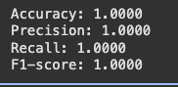

- Develop and fine-tune a Multi-Layer Perceptron (MLP) neural network model with back-propagation using scikit-learn, perform hyper parameter tuning, and assess its performance using various performance measures for a specific machine learning task.

from sklearn.datasets import load_breast_cancer

breast_cancer = load_breast_cancer()

print(breast_cancer.DESCR)

import pandas as pd
from sklearn.preprocessing import StandardScaler

df = pd.DataFrame(breast_cancer.data, columns=breast_cancer.feature_names)

df['target'] = breast_cancer.target

print("Missing values before handling:")
display(df.isnull().sum())

X = df.drop('target', axis=1)
y = df['target']

scaler = StandardScaler()
X_scaled = scaler.fit_transform(X)

X_scaled_df = pd.DataFrame(X_scaled, columns=breast_cancer.feature_names)

print("\nScaled features:")
display(X_scaled_df.head())

from sklearn.model_selection import train_test_split

X_train, X_test, y_train, y_test = train_test_split(X_scaled_df, y, test_size=0.2, random_state=42)

print("Shape of X_train:", X_train.shape)
print("Shape of X_test:", X_test.shape)
print("Shape of y_train:", y_train.shape)
print("Shape of y_test:", y_test.shape)

from sklearn.neural_network import MLPClassifier

mlp_model = MLPClassifier(hidden_layer_sizes=(100,), activation='relu', solver='adam', random_state=42)

from sklearn.model_selection import GridSearchCV

param_grid = {
'hidden_layer_sizes': [(50,), (100,), (50, 50), (100, 50)],
'activation': ['tanh', 'relu'],
'solver': ['sgd', 'adam'],
'alpha': [0.0001, 0.001, 0.01]
}

grid_search = GridSearchCV(mlp_model, param_grid, cv=5, n_jobs=-1)

grid_search.fit(X_train, y_train)

best_params = grid_search.best_params_

print("Best hyperparameters found:")
print(best_params)

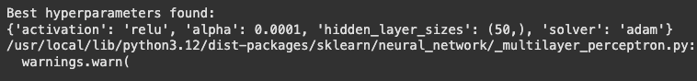
from sklearn.neural_network import MLPClassifier

best_mlp_model = MLPClassifier(**best_params, random_state=42)

best_mlp_model.fit(X_train, y_train)

from sklearn.metrics import accuracy_score, precision_score, recall_score, f1_score

y_pred = best_mlp_model.predict(X_test)

accuracy = accuracy_score(y_test, y_pred)
precision = precision_score(y_test, y_pred)
recall = recall_score(y_test, y_pred)
f1 = f1_score(y_test, y_pred)

print(f"Accuracy: {accuracy:.4f}")
print(f"Precision: {precision:.4f}")
print(f"Recall: {recall:.4f}")
print(f"F1-score: {f1:.4f}")
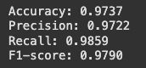

import matplotlib.pyplot as plt
from sklearn.metrics import ConfusionMatrixDisplay

ConfusionMatrixDisplay.from_predictions(y_test, y_pred)
plt.title('Confusion Matrix for MLP Model')
plt.show()
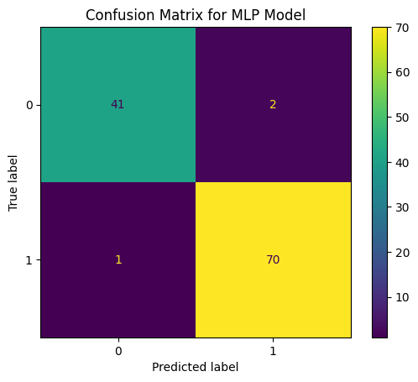

- Illustrate the K-means clustering to cluster the data points for at least five epochs properly.
a. Use the elbow method to determine the optimal number of clusters.
b. Visualize the clusters.
c. Plot the centroids of each cluster.

from sklearn.datasets import make_blobs

X, _ = make_blobs(n_samples=300, centers=3, cluster_std=0.5, random_state=42)
print(X.shape)

from sklearn.cluster import KMeans
import matplotlib.pyplot as plt

inertia = []
for i in range(1, 11):
kmeans = KMeans(n_clusters=i, random_state=42, n_init=10)
kmeans.fit(X)
inertia.append(kmeans.inertia_)

plt.plot(range(1, 11), inertia)
plt.xlabel('Number of Clusters')
plt.ylabel('Inertia')
plt.title('Elbow Method')
plt.show()

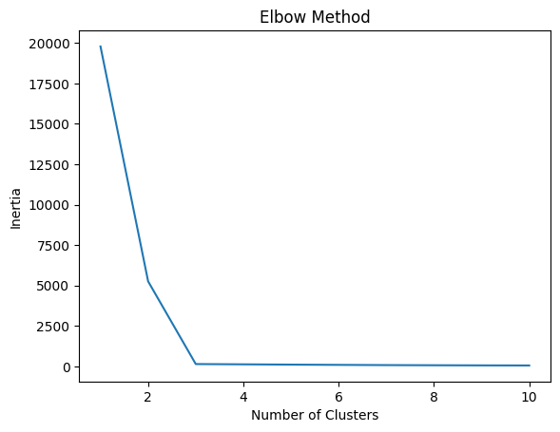

kmeans = KMeans(n_clusters=3, random_state=42, n_init=10)
kmeans.fit(X)
labels = kmeans.labels_
centroids = kmeans.cluster_centers_

plt.figure(figsize=(8, 6))
plt.scatter(X[:, 0], X[:, 1], c=labels, cmap='viridis', s=50, alpha=0.8)
plt.scatter(centroids[:, 0], centroids[:, 1], c='red', marker='x', s=200, label='Centroids')
plt.xlabel("Feature 1")
plt.ylabel("Feature 2")
plt.title("K-means Clustering Results")
plt.legend()
plt.show()

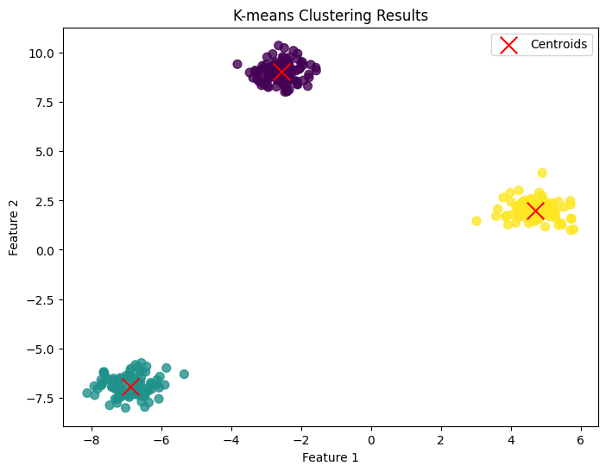
- Illustrate the K-mode clustering to cluster the bank customers.

print(df.dtypes)
print(df.isnull().sum())

categorical_cols = ['job', 'marital', 'education', 'default', 'housing', 'loan', 'contact', 'month', 'poutcome', 'term_deposit']
df_categorical = df[categorical_cols]

display(df_categorical.head())

!pip install kmodes

from kmodes.kmodes import KModes
import matplotlib.pyplot as plt
costs = []
K = range(1, 11)
for k in K:
kmode = KModes(n_clusters=k, init='Huang', n_init=5, random_state=0)
kmode.fit_predict(df_categorical)
costs.append(kmode.cost_)

plt.plot(K, costs, 'bx-')
plt.xlabel('Number of clusters (k)')
plt.ylabel('Cost')
plt.title('Elbow Method for Optimal k')
plt.show()

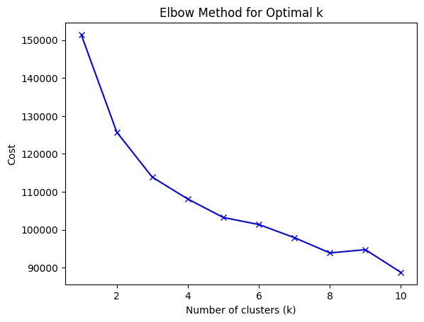

optimal_k = 3
kmode = KModes(n_clusters=optimal_k, init='Huang', n_init=5, random_state=0)
clusters = kmode.fit_predict(df_categorical)
df['kmodes_cluster'] = clusters

display(df.head())

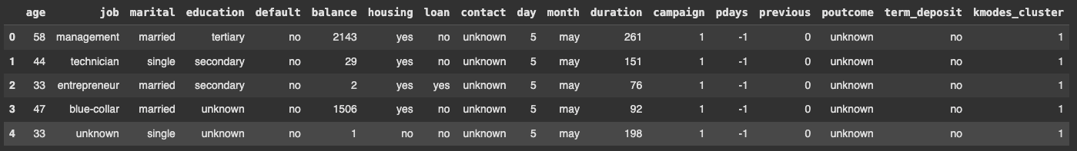
import seaborn as sns

for col in categorical_cols:
plt.figure(figsize=(10, 6))
sns.countplot(data=df, x=col, hue='kmodes_cluster')
plt.title(f'Distribution of {col} by Cluster')
plt.xticks(rotation=45, ha='right')
plt.tight_layout()
plt.show()
